Audio Content Explorer

Naveen Tiragati
School of Computing and Engineering
University of Missouri Kansas City
Kansas City, MO
ntdpm@umsystem.edu

Kalyan Kumar Saiempu
School of Computing and Engineering
University of Missouri Kansas City
Kansas City, MO
ks6hp@umsystem.edu

Vijay Agavinti
School of Computing and Engineering
University of Missouri Kansas City
Kansas City, MO
vactp@umsystem.edu

Anil Kumar Kochera
School of Computing and Engineering
University of Missouri Kansas City
Kansas City, MO
akkw32@umsystem.edu

Abstract— Youtube is a great place for many content creators to upload their videos and allows viewers to comment, like, and share the video. When there are an immense number of comments on a video, it is practically impossible to reply to each and every one by the creator, so we provide an ML solution that replies to comments automatically. Moreover, it is always a great idea to get a summary of all the comments section on a Youtube video. Also, this corpus of comments provides a very interesting opportunity to grab the overall sentiment of the comment section and ideas for future videos. And, finding interesting topics from the comments section is one of the great ways to discover ideas for their next Youtube video which we achieve from this project.
Keywords—comments, replies, ideas, sentiment analysis, summary

Motivation and Significance
Founded in 2005, Youtube has grown to become the second-largest search engine in the world (behind Google) that processes more than 3 billion searches per month. [[1]] It is, however, generally a myth how the Youtube algorithm works, and what makes a video get views and be recommended over another. In fact, YouTube has one of the largest and most sophisticated industrial recommendation systems in the existence [[2]]. For new content creators, it is a challenge to understand why a video gets video and others do not. There are many "myths" about the success of a Youtube video [[3]], for example, if the video has more likes or comments, or if the video is of a certain duration. It is also worth experimenting and looking for "trends" in the topics that Youtube channels are covering in a certain niche.
We have decided to gain some insights on this topic which might be useful for other new content creators. The scope of this small project is limited to data science channels. Therefore, this project will explore the statistics of around 10 most successful data science Youtube channels. Using techniques such as topic modeling, Text summarization, and sentiment analysis, we will derive some key information about the video that is uploaded by the Youtuber. This will not only help them get a clear understanding of their featured video but also helps them get ideas for new videos.

objectives
Within this project, we would like to explore the following:
Getting to know Youtube API and how to obtain video data and then analyzing video data and verifying different common "myths" about what makes a video do well on Youtube, for example: Does the number of likes and comments matter for a video to get more views? Moreover, does the video duration matter for views and interaction (likes/ comments)? This is a serious question that we want to find. Along with it, does title length matter for views? and how many tags do good-performing videos have? What are the common tags among these videos? are some of the important questions that a YouTuber has. They also would be very interested to know across all the creators we take into consideration, how often they upload new videos. On which days in the week? Explore the trending topics using NLP techniques and find which popular topics are being covered in the videos (e.g. using word cloud for video titles)

Adding to that, which questions are being asked in the video comment sections? These are the objectives we will primarily focus on. Also, we would like to see the whole summary of their comments under their channel. And also, perform sentiment analysis and also convert video to audio and convert the audio to text and perform topic modeling on it. Performing sentiment analysis helps us identify the viewer’s opinions on the channel and with the help of metrics we find from topic modeling and text summarization, we can try to suggest ideas for the next videos.

Topic Modeling
It is a statistical modeling technique that is used to find some abstract topics that are present in a document. To achieve this, we perform Data preprocessing – in this step, we create our tokenized data i.e, splitting data into words and removing punctuations, stopwords, words with less frequency, and words are stemmed to bring them to their root form. We then use the Bag of Words technique to count the number of occurrences of the words. On this, we perform the TF-IDF technique and ran LDA using Bag of words and LDA using TF-IDF. We checked their performance.

Text Summarization
In our project's scope, we deal with many comments from different users. As a Youtube channel owner, getting a picture of the summary of people’s comments on their Youtube channel is really valuable. This allows them to get an idea of the user’s pulse and how well it is being received. So, we are implementing a text summarization module in our project where we collect comments from a channel and give them a summary of all the comments they had to date on all their Youtube videos. We achieve text summarization using a state-of-the-art model, PEGASUS. [4] Pegasus is a model developed by Google in 2020. It is a standard Transformer encoder-decoder. This model is fine-tuned to perform very impressively on text summarization. The way it works is, it masks or removes the important sentences and generates one output sequence from the remaining sentences which work similarly to an extractive model. Its pretraining objective is to generate a text that is similar to a summary. Now, for this to happen on huge corpora, the designers used a sequence to sequence self-supervised objectives. Following BERT, MLM is used in training to train the transformer encoder along with GSG (Gap Sequence Generation). Fig 1.1 depicts the architecture of the model we are using.

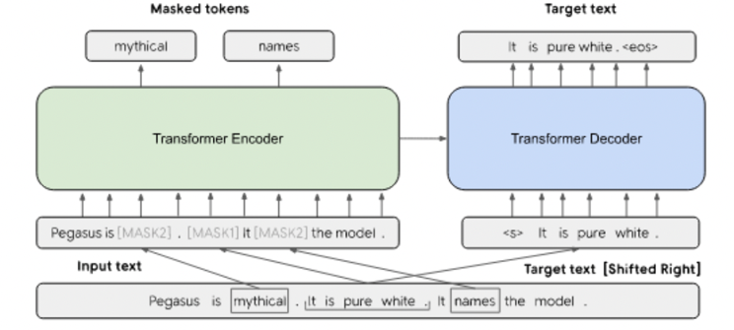
Fig 1.1 Pegasus Model Architecture

Auto Chapters
Converting a Youtube video to audio and converting it into text will help us find some key analysis that helps viewers as well as the Youtuber about each part of the video rather than the whole video summary. This helps us understand the summary of each part of the video. We are using the Assembly AI endpoint to perform auto chapters that allow us to achieve this. It first takes the first segment of the audio file and creates a logical “chapter” based on the topic conversation. The following picture 1.2 depicts the idea of Auto Chapters.
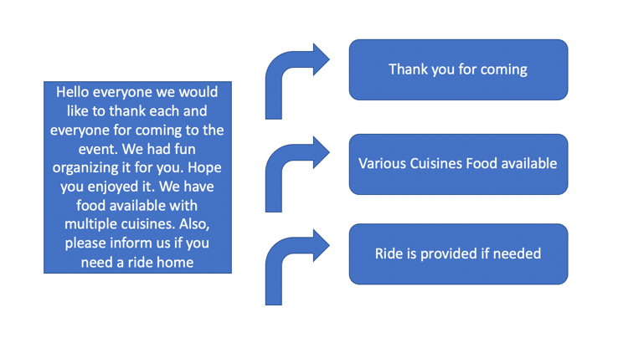
Fig 1.2 – Auto Chapters
We decided to obtain the video metadata via Youtube API for the top 10-15 channels in the data science niche (this includes several small steps: create a developer key, request data and transform the responses into a usable data format) Preprocess data, and engineer additional features. 3. Perform EDA and apply NLP techniques, and ICP Learnings. 4. Show the conclusions in a visually appealing dashboard.

Video to Audio Conversion
Following are the steps to achieve this,
Stage 1: Video to Audio format
We are using 3rd party API for converting video (MP4) format into audio format (MP3)
Stage 2: audio to text
Pre-requisites:
I. Python 3.7
II. FFmpeg
III. Libraries: os and speech_recognition
Step 1: Prepare the directory
Create a new folder and add some video files.
Step 2: Import libraries
Import the required libraries.
Step 3: Command for video conversion
Using FFmpeg to convert the video file to audio. First, convert this to mp3 format and then will transform it to the wav format, as wav format allows you to extract better features.
Step 4: Execute video conversion commands
Execute these commands using the ‘os’ library
Step 5: Load the wav file
Load the wav file that was created in the above step.
Step 6: Process the wav file
Lastly, as per required, set the duration of the audio you want for further processing.

Results

Automatic Replies
We first focused on getting automatic replies to comments that are given by viewers of a video. For this, used a newspaper corpus to test our code. This initially gave us pretty decent results and we were able to create a chatbot that learns the context from the corpus and then creates its own vocabulary to reply to the user input questions. So, in the first step, we performed sentence tokenization and then created a few methods that are responsible for greeting the user and saying goodbye based on the appropriate words given in a list. We then had a bot response method that will analyze the context of the question and replied with appropriate answers. As we learned from our classes, we used CountVectorizer and cosine_similarity for our implementation. Fig 1.3 below shows a short demo of bot greeting.
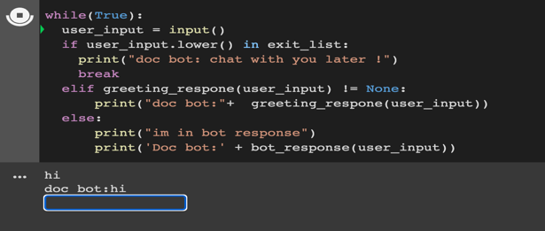
Fig 1.3 – Automatic Reply with chat Bot

Text Summarization
We were able to perform text summarization for the video transcripts and show a summary of each chapter in a video. We showed these results on a UI that will show the summary of transcript chapters as per the conversation flow. Fig 1.4 shows the result of Text summarization on a video. We also provided an option to hear the summary as audio. Once the transcript is captured and converted to text, we perform the text summarization technique and give the option to hear it in audio format.

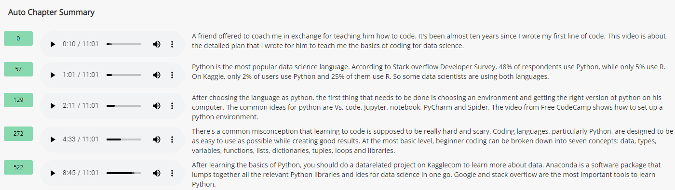
Fig 1.4 – Text Chapters Summary

Sentiment Analysis
We can see the entire sentiment of the video in the following image below. We can see that on the x-axis we have the total number of counts of the sentiment words and on the y-axis, we have the sentiment. This gives a clear picture of how well the video is received by the viewers. If there is any censored content, we can avoid it and we can also add a filter for analysis. Fig 1.5 shows the UI for sentiment analysis.

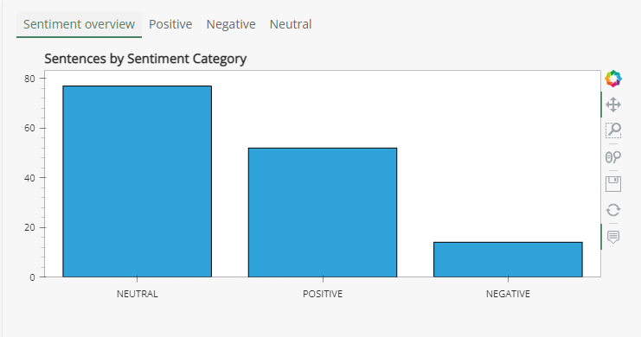
Fig 1.5 – Sentiment Analysis

Topic Modeling
Using our learning, we created a topic modeling chat that will display all the words with the importance that indicate the topics in the video transcript. We also intend to implement the same in the comments section which will showcase all the topics that viewers are engaging on and provides ideas for the next videos. Fig 1.6 shows the UI result of Topic Modeling. To achieve this, we used the text file of the transcript and and tokenized the data. On that we performed normalization i.e, converting a word to its canonical form. This process included stemming and lemmatization. On this data, we removed the noise in the data such as hyperlinks, punctuation marks etc. Now, we created a word density and on it, we implemented the most popular technique NaiveBayes is used to perform sentiment analysis.

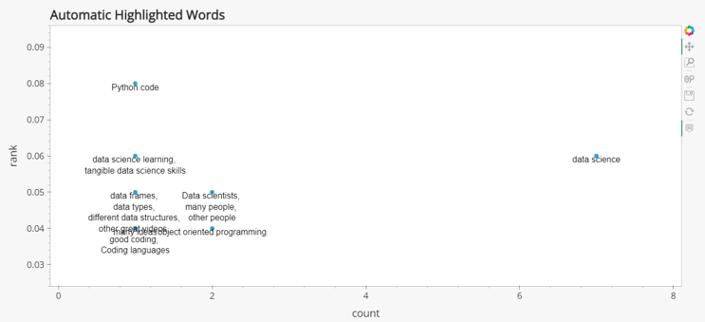
Fig 1.6 – Topic Modeling

On top of the scatterplot that shows the topics that were most talked about, we show a word cloud that shows cases of the most used words in the transcript and gives a profound understanding of the video synopsis. Fig 1.7 shows the word cloud with a slider, that allows the user to select a number of words for their analysis as they require.

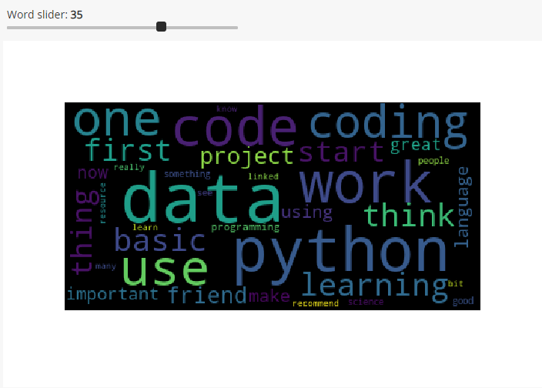
Fig 1.6 – Word Cloud of most used words

GitHub: https://github.com/vijay9237865/Social_media_Comments_Analysis

Planned Work
Our plan is to implement and extend the indicated parts in our report and make it a full fledge project that includes more visualizations and a UI page that allows us to navigate to different pages and analysis results on the comments of a Youtube video. We currently are working on using all the implementations used on the audio transcript to the comments collected from various videos. We have the comments ready and we are working on giving automatic replies to people who ask questions. We were able to implement the chatbot that answers user’s questions on the audio transcript data and we will polish it more so it will be used on the comments that we collect.

Conclusion
In this project, we were able to demonstrate all the techniques we learned from ICPs and implement them in our own project which yields very interesting results. We were able to successfully complete topic modeling, text summarization, sentiment analysis and automatic replies to the video transcripts.

YouTube Video Link:
Link: https://docs.google.com/document/d/1z9_BJsJDzqQxXilvf8hUCloxI-M_e0am_R4szZ60qVM/edit?usp=sharing

PPT Link
Link: https://docs.google.com/document/d/1z9_BJsJDzqQxXilvf8hUCloxI-M_e0am_R4szZ60qVM/edit?usp=sharing

References
- https://www.mushroomnetworks.com/infographics/youtube---the-2nd-largest-search-engine-infographic/
- https://dl.acm.org/doi/10.1145/2959100.2959190
[3] https://vidiq.com/blog/post/5-youtube-algorithm-myths-youtubers-need-to-know-about/
[4] https://arxiv.org/pdf/1912.08777.pdf
[5] https://towardsdatascience.com/pegasus-google-state-of-the-art-abstractive-summarization-model-627b1bbbc5ce
[6]. https://www.assemblyai.com/docs/audio-intelligence#auto-chapters

